**Whatsapp based ordering**

**Existing Flow**

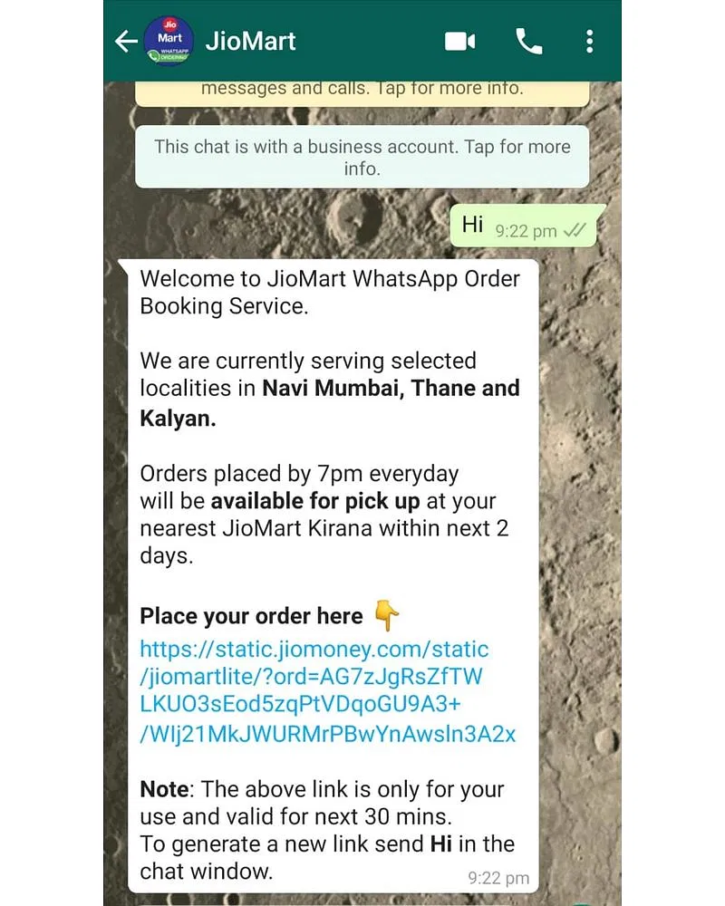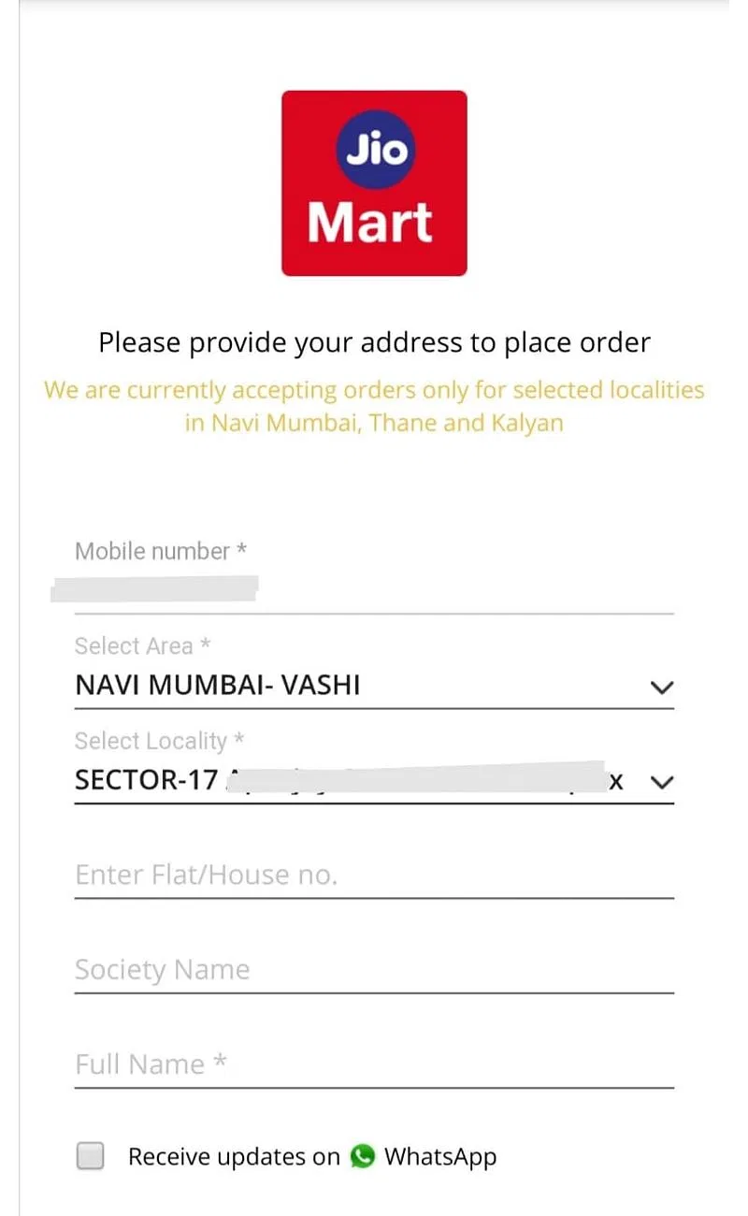

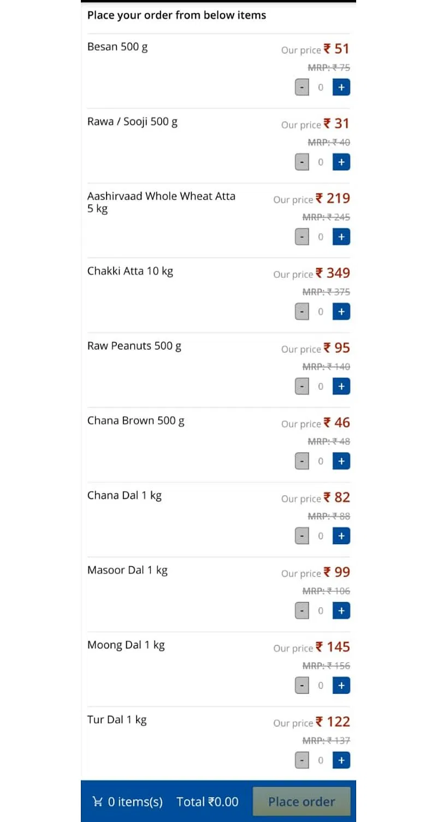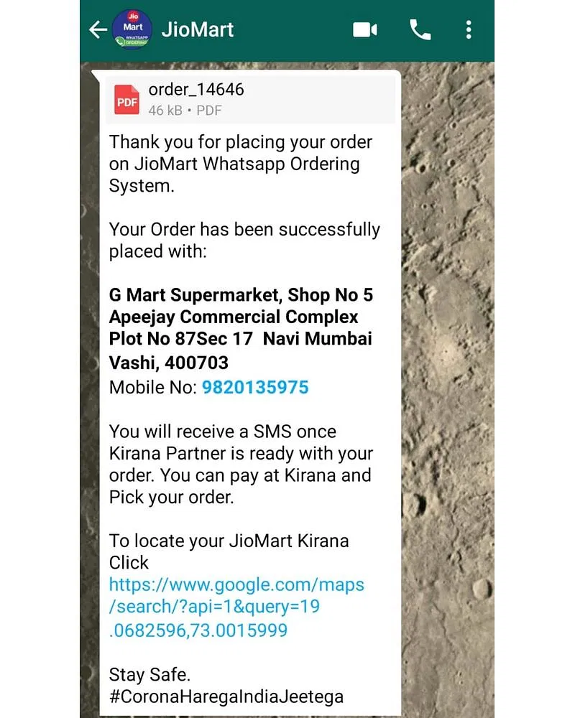



**Likewise once a link is generated we can take the customer to the platform that we’ve created for the QR restaurant idea and then onto the ongo payment gateway. In this way, the flow will be completed.**

**UI Limitations**

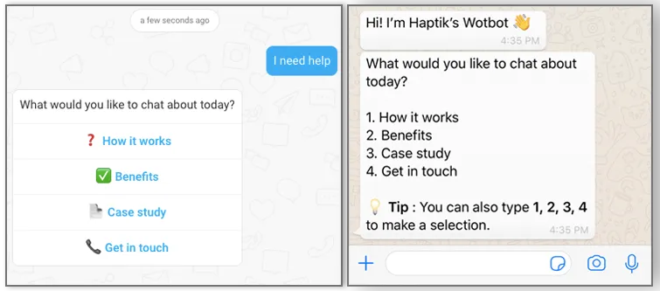

WhatsApp only supports text. Therefore, any WhatsApp experience needs to be designed based on textual inputs from the user. This means the bot flow will be user-driven (Users typing and asking questions) and *not* bot-driven (The bot suggesting intuitive quick replies and buttons).

**Getting WhatsApp business API**

Not everyone can get WhatsApp Business API. The service is intended for well-established medium and large businesses. Industries favored by [WhatsApp include real estate](https://landbot.io/blog/whatsapp-real-estate-chatbot/), financial services, [eCommerce](https://landbot.io/blog/whatsapp-ecommerce-use-cases/), retail, [travel & hospitality](https://landbot.io/blog/whatsapp-travel-hospitality-use-cases/), [education](https://landbot.io/blog/whatsapp-education-use-cases/), and telecommunications.